- Alarm: PH Box Presence UDC
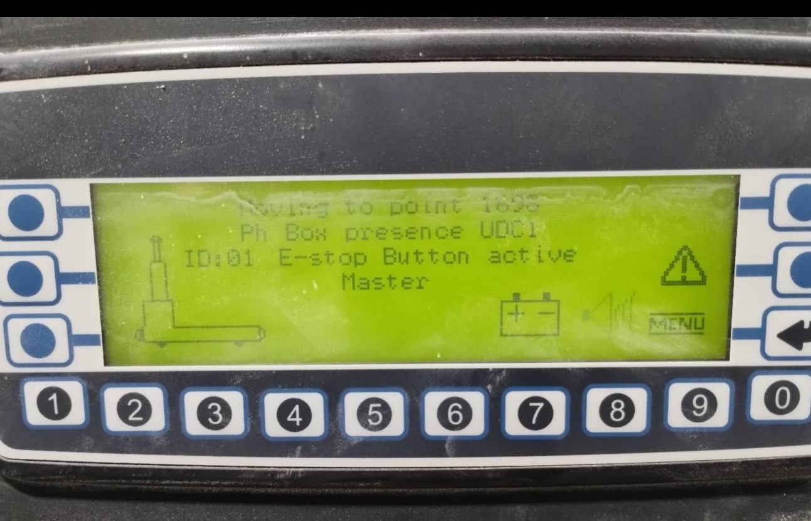
PH Box Presence UDC
Use the override button on the remote to drive the AGV away from the obstruction or platform.
If the override sequence doesn’t engage, try using a different remote.
Once the AGV is clear of the obstruction, return to Automatic Mode by pressing:
Blue button
Green button
This will re-initiate the automatic sequence.

